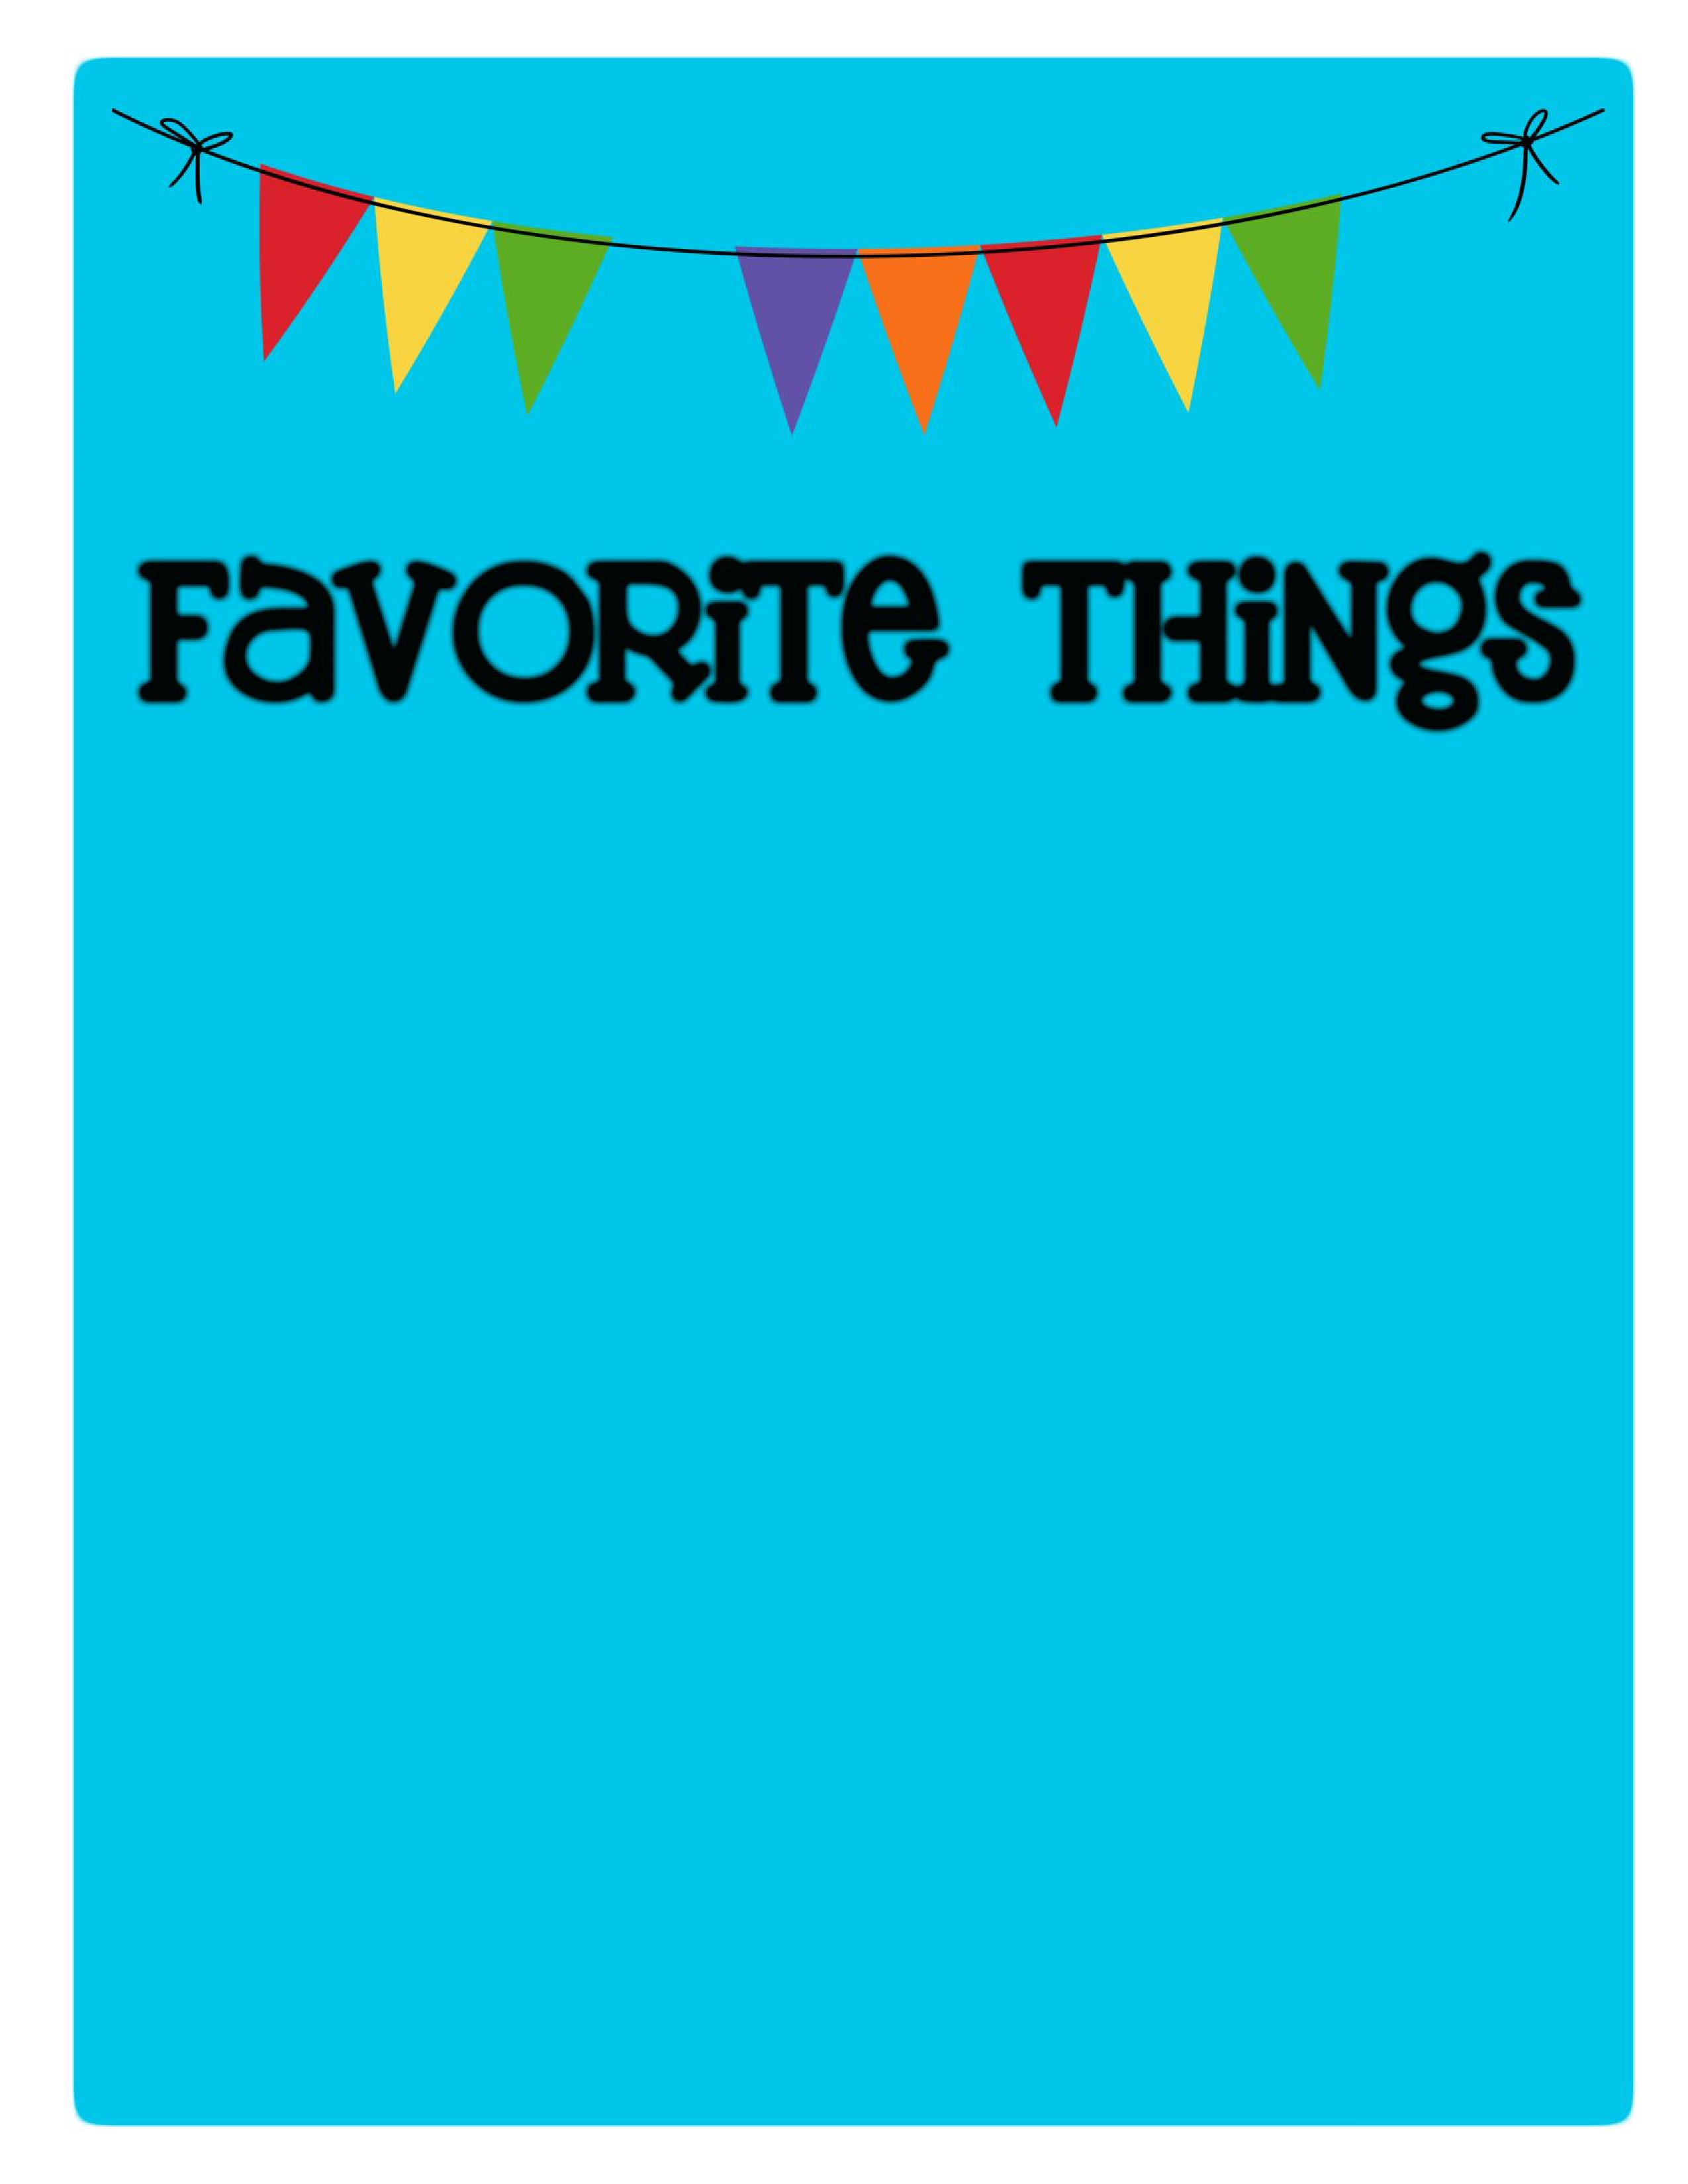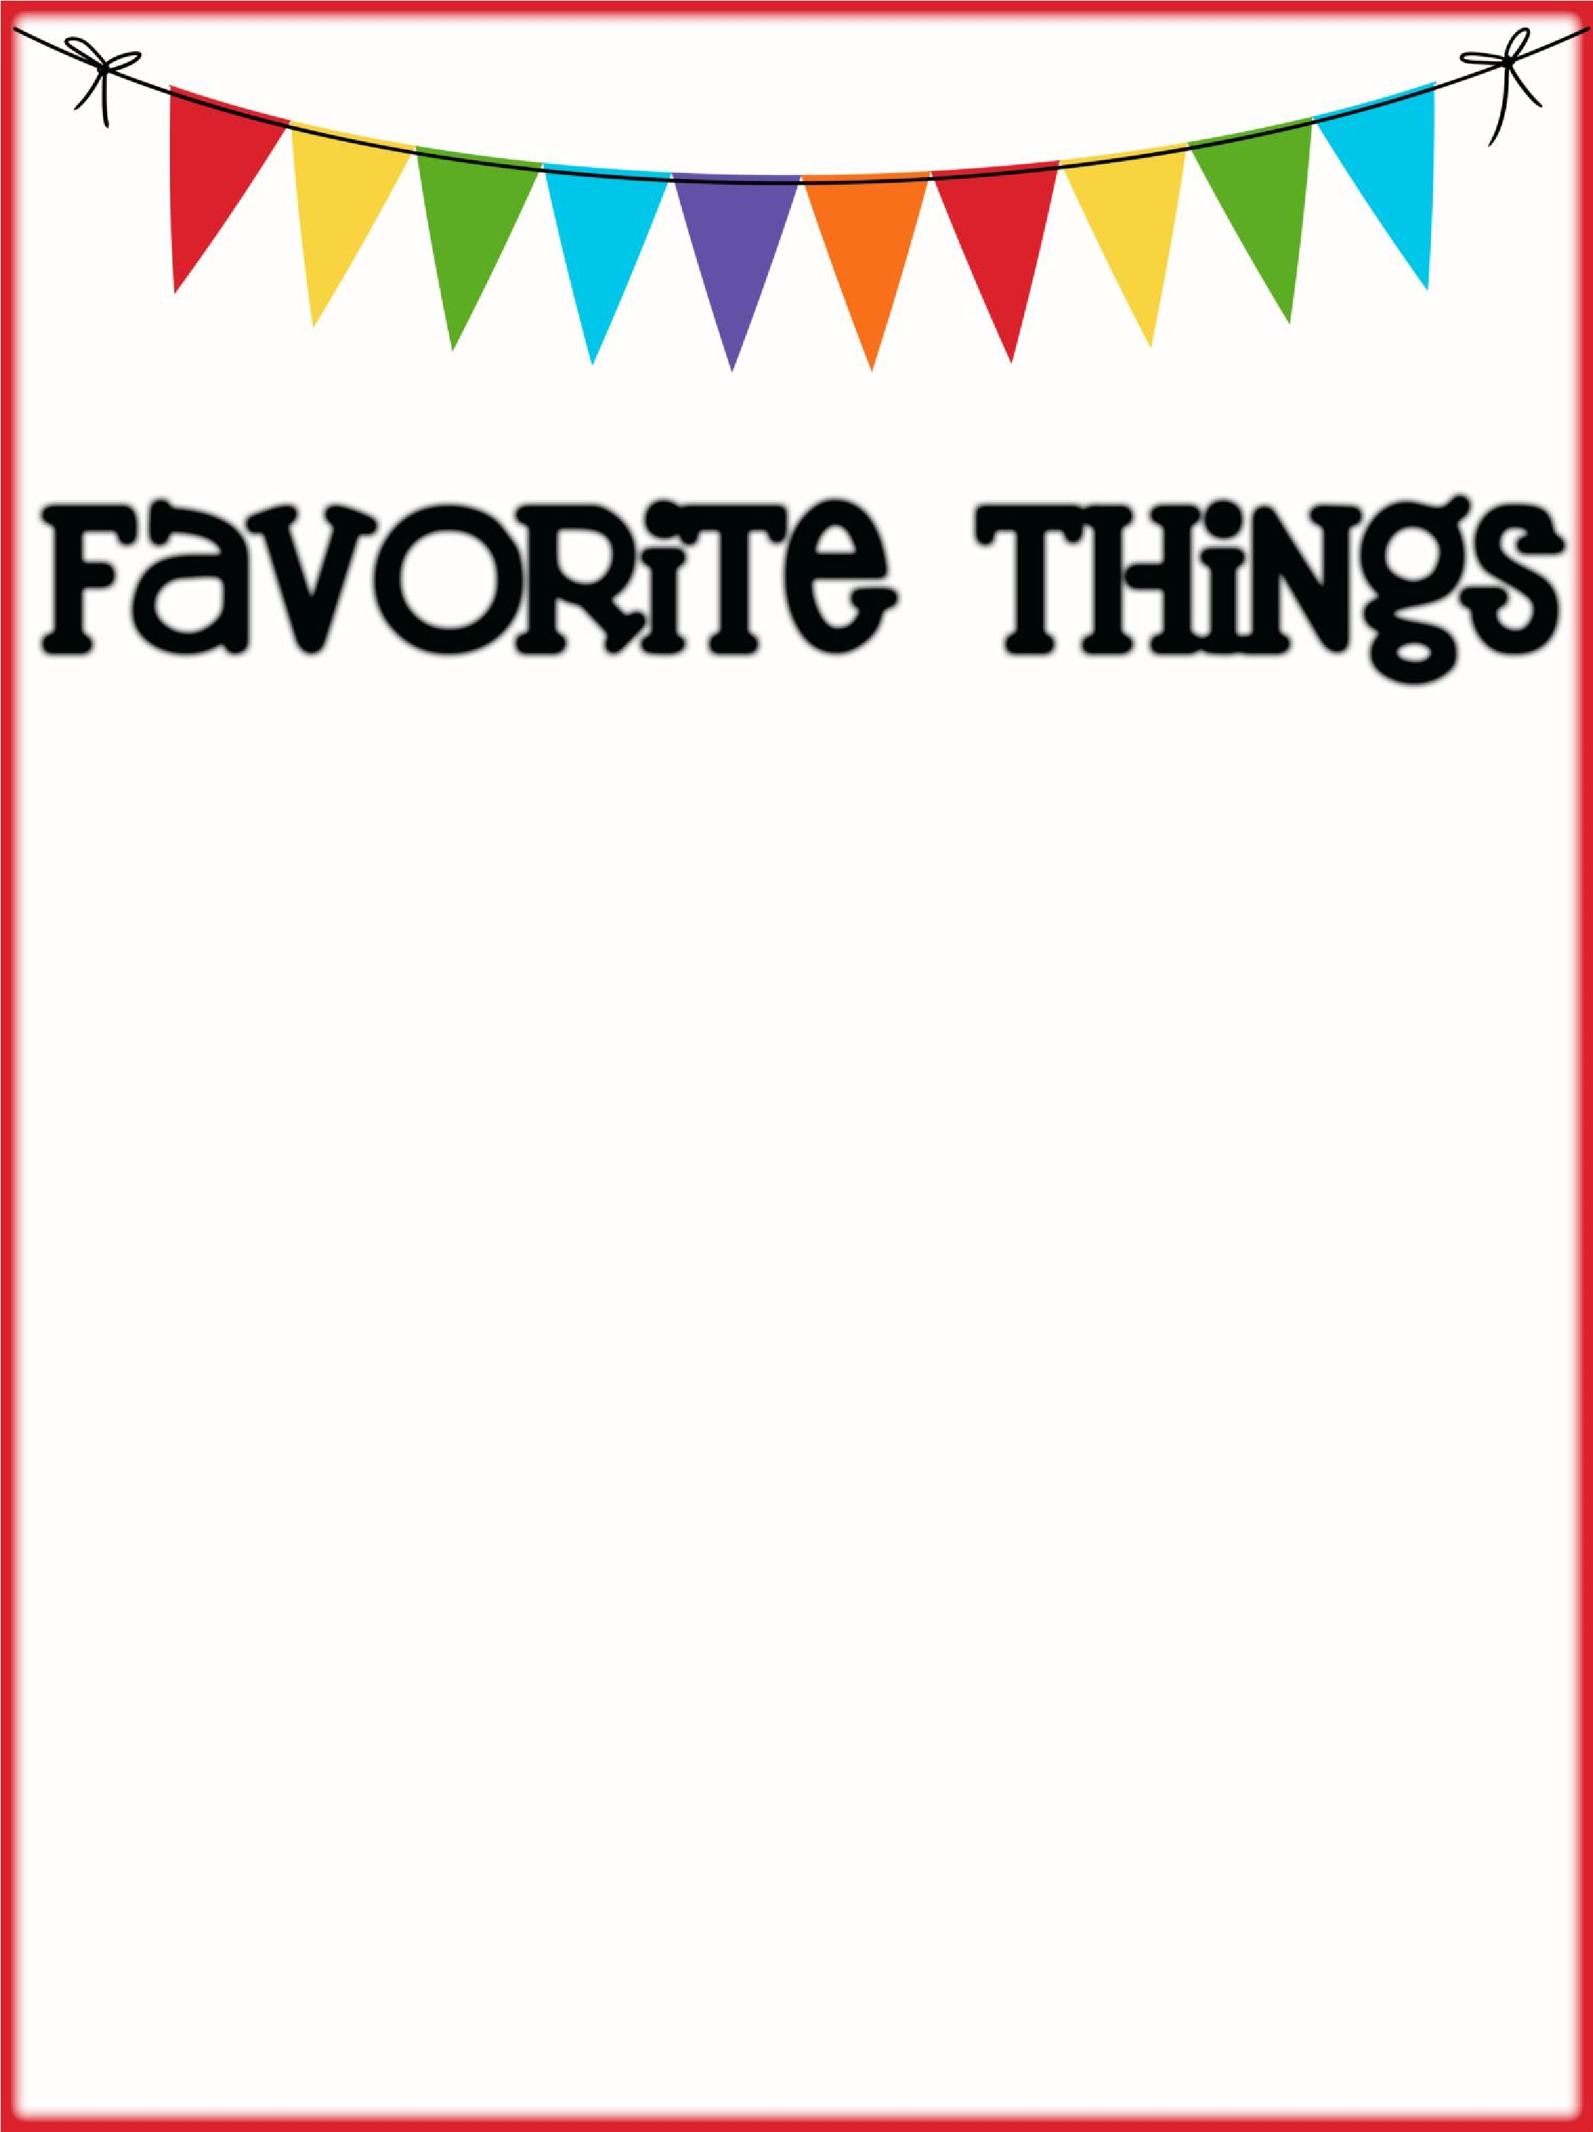

Name: Andrea Hale _________________________

Birthday: _August 29th _________________________________________

Favorites

Places to Eat: ___In & Out, Salad & Go, Someburros, Barros _______________________________________________

Places to Shop:

_Hobby Lobby, Michaels, Kohls, Target

Favorite Gift Cards:_ Black Rock & Starbucks

Drinks :

Starbucks

:

___Cold brew w/chocolate cold foam, Iced coffee black ________________________________

Sonic

:

__Unsweetened Iced Tea ____________________________________

Other

:

___Salad & Go Arnold Palmer

Scents (lotion, Scentsy, etc.): any scent except vanilla

Candy/Snacks: __Chex Mix, Boom Chicka Pop, anything peanut butter ________________________________

Cookies/Cake: Carrot Cale

Flowers

:

____

Lavendar roses, Hibiscus, Daisies

Hobbies/Collectibles: ___Anything Crafty

Other Wish List Items: _collect crosses and Starbucks cups